SEMESTER ONE
Papers written by Australian Maths Software

YEAR 12
MATHEMATICS SPECIALIST
REVISION 1
UNIT 3
2016
Section Two
(Calculator–assumed)

Name: _________________________________

Teacher: ________________________________

TIME ALLOWED FOR THIS SECTION

Reading time before commencing work: 10 minutes
Working time for section: 100 minutes

MATERIAL REQUIRED / RECOMMENDED FOR THIS SECTION

To be provided by the candidate
Standard items: pens, pencils, pencil sharpener, highlighter, eraser, ruler.
Special items: drawing instruments, templates, notes on up to two unfolded sheet of A4 paper, and up to three calculators approved for use in the WACE examinations.

IMPORTANT NOTE TO CANDIDATES
No other items may be taken into the examination room. It is your responsibility to ensure that you do not have any unauthorised notes or other items of a non–personal nature in the examination room. If you have any unauthorised material with you, hand it to the supervisor before reading any further.

To be provided by the supervisor
Question/answer booklet for Section Two.
Formula sheet retained from Section One.
Structure of this examination

 | Number of questions available | Number of questions to be answered | Working time (minutes) | Marks available | Percentage of exam
Section One  Calculator—free | 5 | 5 | 50 | 50 | 35
Section Two  Calculator—assumed | 11 | 11 | 100 | 100 | 65
Total marks |  |  |  | 150 | 100

Instructions to candidates

1. The rules for the conduct of this examination are detailed in the Information Handbook. Sitting this examination implies that you agree to abide by these rules.

2. Write your answer in the Question/Answer booklet.

3. You must be careful to confine your responses to the specific questions asked and to
follow any instructions that are specific to a particular question.

4. Spare pages are provided at the end of this booklet. If you need to use them, indicate in the original answer space where the answer is continued i.e. give the page number.

5. Show all your working clearly. Your working should be in sufficient detail to allow your answers to be checked readily and for marks to be awarded for reasoning. Incorrect answers given without supporting reasoning cannot be allocated any marks. For any question or part question worth more than two marks, valid working or justification is required to receive full marks. If you repeat an answer to any question, ensure that you cancel the answer you do not wish to have marked.

6. It is recommended that you do not use pencil, except in diagrams.

7. The Formula Sheet is not to be handed in with your Question/Answer booklet.

6. (6 marks)
Given 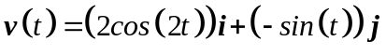
(a) find the expressions for 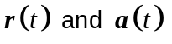given 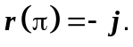 (3)

(b) determine 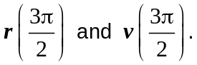 (2)

(c) show that 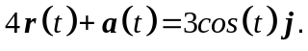 (1)

7. (20 marks)
The position vector of a particle at time is given by 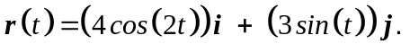
The relationship is graphed below:
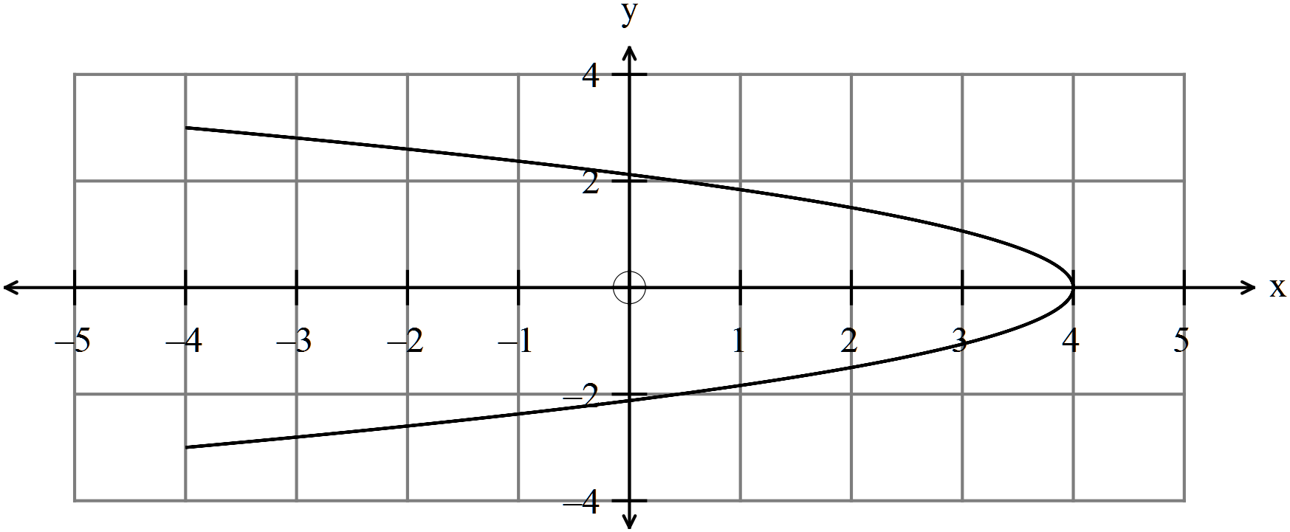

(a) Determine the position of the particle at  and indicate the direction of
travel of the particle on the diagram. (3)

(b) Find an expression for the velocity of the particle and sketch the velocity
vector on the graph for . (4)

(c) Find the expression for the acceleration of the particle. (2)

(d) Determine the position of the particle when 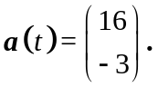 (2)

(e) Determine whether or not 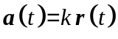. (2)

(f) Determine the times, if any, on 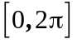when 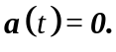 (4)

(g) Convert the position vector 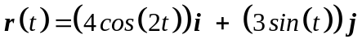 into the
corresponding Cartesian equation. (3)

8. (10 marks)
(a) Find the vector equation of the plane that contains the points
(2)

(b) Find the Cartesian equation of the sphere containing points by inspection. (2)

(c) A cricket ball was hit from 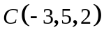 with a velocity of 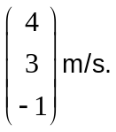
Paul, at 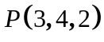 leapt towards the ball with a velocity of 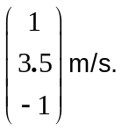
(i) How many seconds will it take for the ball to hit the ground? (2)

If Paul reaches the ball, he will catch it.
(ii) Show that Paul catches the ball at ground level. (3)

Paul’s Dad was telling the story and was inclined to exaggerate.

(iii) How far did he suggest Paul had leapt? (1)

9. (6 marks)

(a) (i) Find the vector equation of the line that contains the point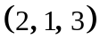 and is
parallel to the line 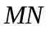 where  has coordinates 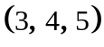 and  has
coordinates 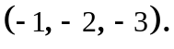 (2)

(ii) Find the corresponding Cartesian equation of the line. (2)

(b) Determine whether or not the lines 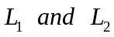 intersect. If they do, find the point of intersection.
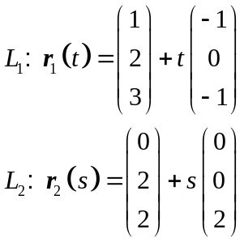
(2)

10. (9 marks)

(a) Use the vector product to find the area of the trianglegiven the points (4)

(b) Find the ratio 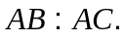 (2)

(c) The midpoints ofandare 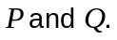
Prove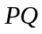 is parallel to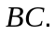 (3)

11. (13 marks)
(a) If 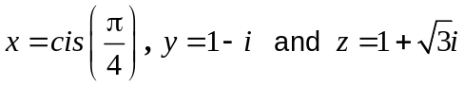, simplify 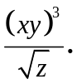 (4)

(b) Describe fully the shaded region graphed on the set of axes below. (3)
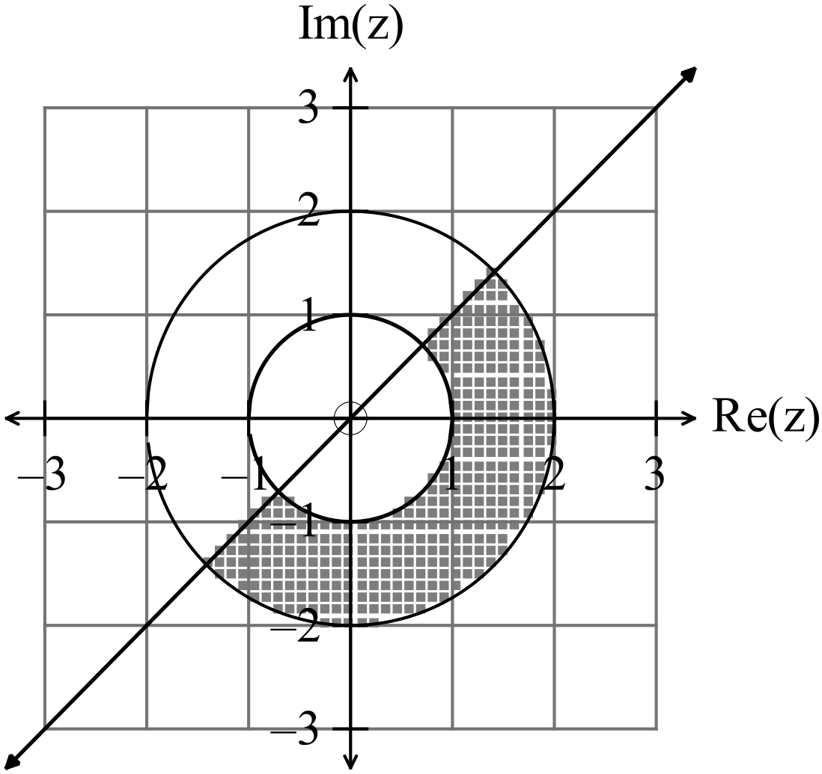

(c) (i) By letting 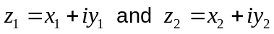 show that 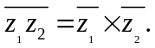 (3)

(ii) If 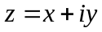 then find 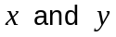 if 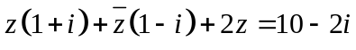 (3)
.
12. (6 marks)

A naughty Year 10 boy, Tom, kicked a football directly towards his English classroom
window during his lunch break. Tom kicked the ball with a velocity of 20 m/sec at an
angle of 60⁰ from a height one metre off the ground from 50 metres away.
The window was at a height of 5.6 metres above the ground.
HINT: 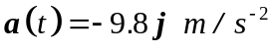
(a) Is it possible that Tom kicked the ball through the window? (5)

The deputy was on lunch duty and left the English building three seconds after Tom kicked the ball

(b) Is it possible the deputy saw the ball in flight? (1)

13. (14 marks)

Given the functions 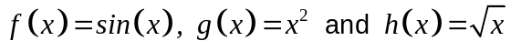
(a) (i) find 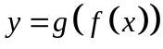. (1)

(ii) sketch on the set of axes below. (3)

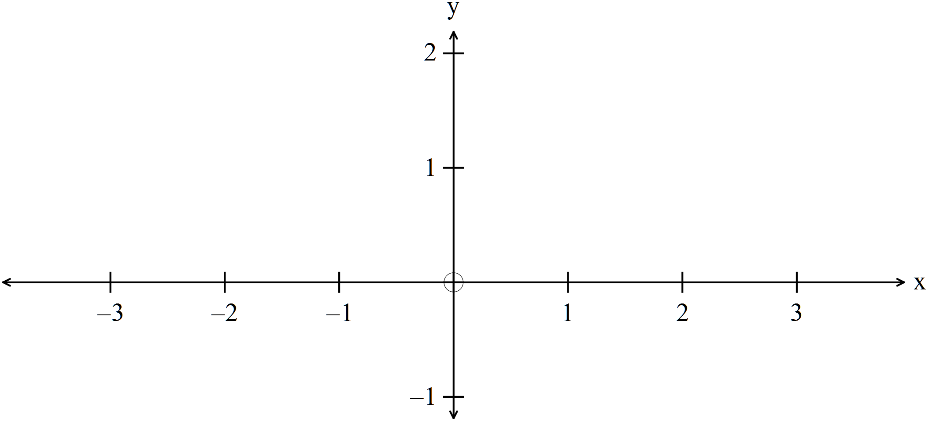

(iii) determine the maximum value of such that is a one to one
function for 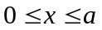. (2)

(iv) sketch the inverse of on the set of axes above.
Label each graph. (2)

(b) Given 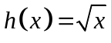,
(i) determine the equation of the inverse function 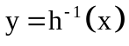 (1)

(ii) write down the range of the inverse function 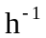. (1)

(c) Find 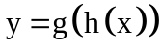and hence determine where the function is defined on 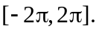
(2)

(d) (i) Sketch 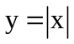 on the set of axes below. (1)

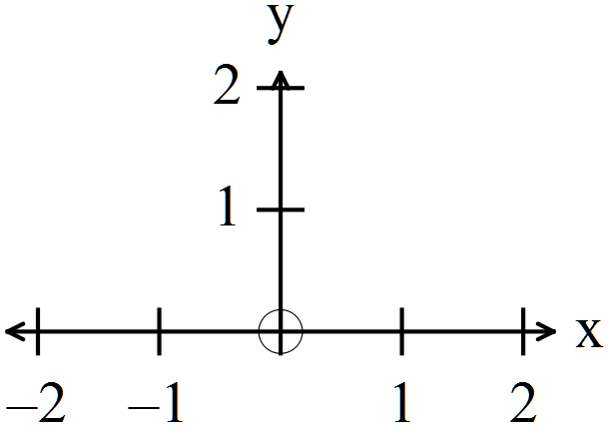

(ii) Explain why the function has no inverse. (1)

14. (7 marks)

(a) Find such that 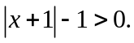 (2)

(b) Solve 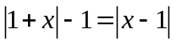. Show all working. (5)

15. (4 marks)

Determine the equation of the function graphed below: (4)

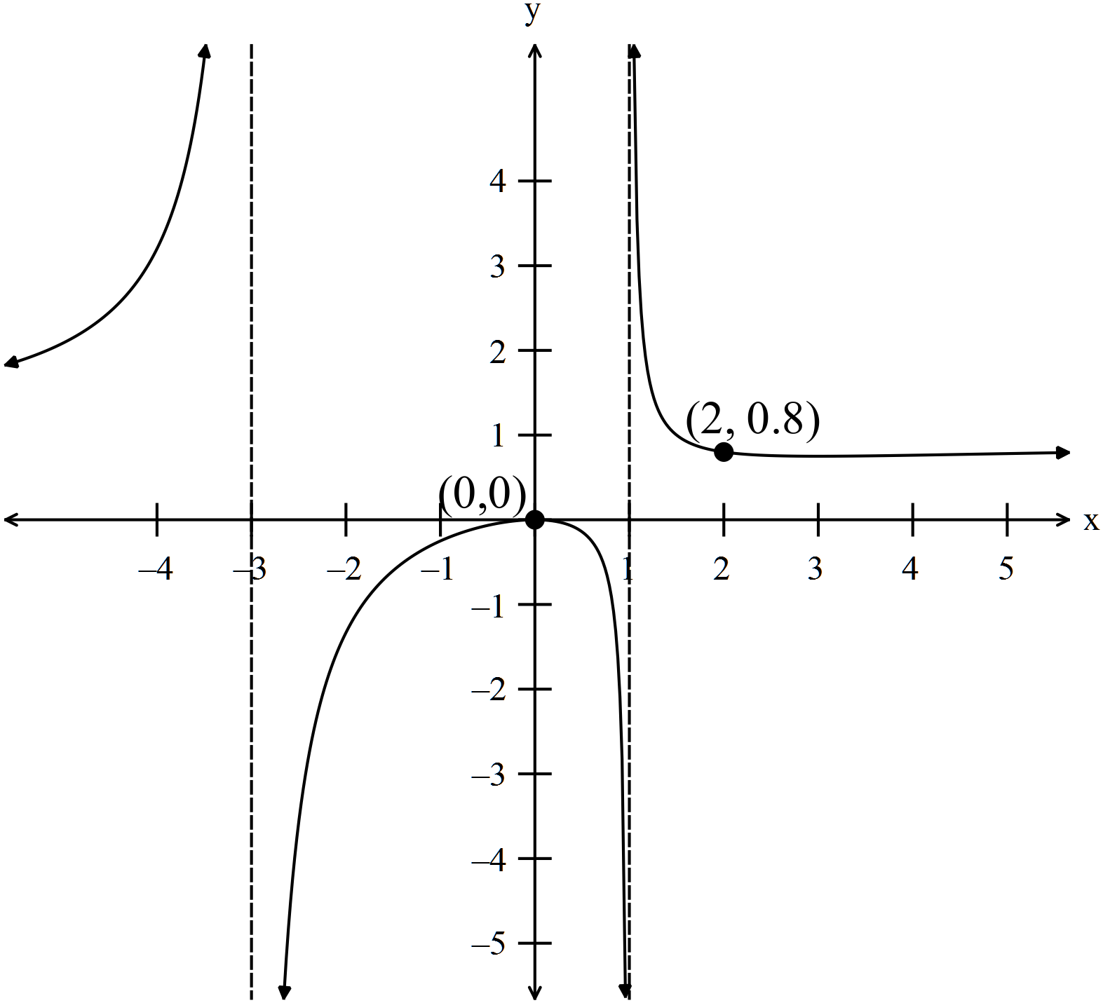

16. (5 marks)

(i) Use your calculator to complete the following table. (2)
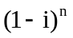
1

2

3

4

5

6

7

8

9

10

(ii) Comment on any patterns found. (3)
NB Much further investigation is required to determine all the patterns.

END OF SECTION TWO

